Linux File Permissions (Linux file ruxsatlari)
LFP 3 ta guruhga bo’linadi :
Permissons Misson
OWNER read
GROUP write
OTHERS execute
Mison uchun:
drwxrwxr-x 3 cr7devops cr7devops 4096 Jan 16 08:21 file4

d rwx rwx r-x - rw- rw- r--
d – directory not a file - → file
rwx – (Owner) read, write, execute rw- → (owner) read, write
rwx - (Group) read, write, execute rw- → (group) read, write
r-x – (All users) read, execute r-- → (all users) read

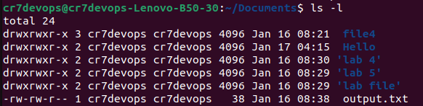

How to change permissons ?

Chown (changing owner)

-rw-rw-r-- 1 cr7devops cr7devops 38 Jan 16 08:38 output.txt
Owner : cr7devops → travis

--sudo chown travis output.txt
-rw-rw-r-- 1 travis cr7devops 38 Jan 16 08:38 output.txt

Update Group name as well:
--sudo chown travis:travismedia output.txt
-rw-rw-r-- 1 travis travismedia 38 Jan 16 08:38 output.txt

Chmod (change mode)
Linux scoring system
r = 4 - rw- rw- r--
w = 2 6 6 4
e = 1

- sudo chmod 774 output.txt

